IT1060 – Software Process Modeling 2023 - May

# Assignment 2 Certify Sheet



I hereby certify,

The attached is my own work and no further changes will be made. I have contributed in this assignment to the best of my ability.

And I understand,

I may be subject to student discipline processes in the event of an act of academic misconduct by me including an act of plagiarism or cheating.

Student Details:

|  |  |  |  |
| --- | --- | --- | --- |
| **Student Name** | **Student Registration** | **Date** | **Signature** |
| **Number** |
| S.PIRANAVAN | IT22153654 | 28.05.2023 |  |

1. Use case diagram

|  |  |  |
| --- | --- | --- |
| **IT22153654** | | |
| **Use case ID** | OTT_C_1 | |
| **Use case Name** | Create timetable | |
| **Summary** | Give the timetable | |
| **Priority** | 1 | |
| **Preconditions** | Lecturer needs to login his or her account | |
| **Primary Actor(s)** | Coordinator | |
| **Trigger** | Trainee teacher follow their lecture properly | |
| **Main Scenario** | **Step** | **Action** |
| **1** | Login to the database |
| **2** | Enter in to the User Data Folder |
| **3** | Gather all user data files |
| **4** | Create the lecture timetable |
| **5** | Give the module access to lecturer |
| **Extensions** | **Step** | **System Action** |
| **3a** | If the email is not valid, the system prompts an error |
| **Open Issues** | **1** | Should the system ask if the user is confident about the  information filled |

Part 1

1. Activity Diagram

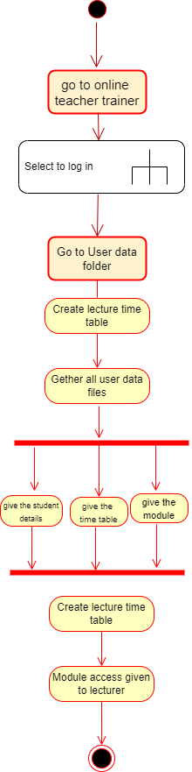

1. Sub activity

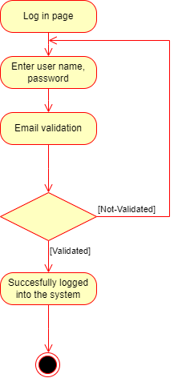

Part 2

1.

2.Activity Diagram with Partitioning

